December 16, 2019

Due date: December 23, 2019

Basics of Electrical Circuits

Homework #2

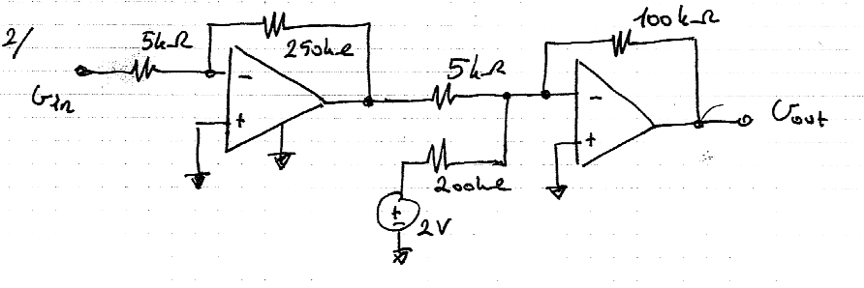1-

Find the expression which relates Vout to independent sources in the circuit given above.

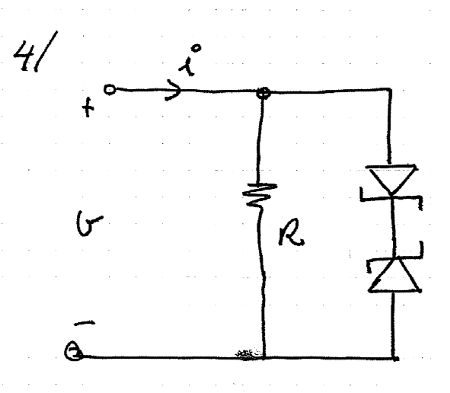2-

Find the nonlinear i-v characteristic of the 2-terminal given above.

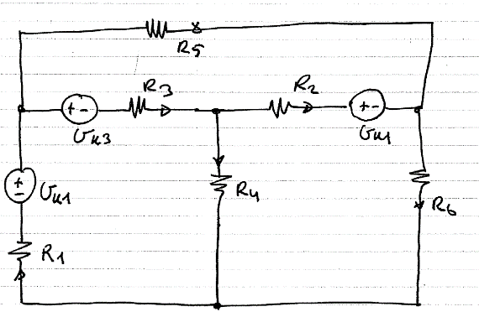3-

Using mesh current method, find the total power of the independent sources.